**Batch Processing**

it has ability to process the messages in batches. In your application you can initiate a batch job create individual records from the messages. Then it perform action on the individual records

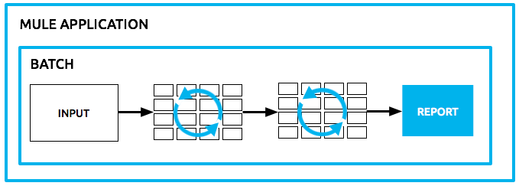

Batch process needed when

• integrating data sets, small or large, streaming or not, to parallel process records.

• Synchronizing data sets between business applications, such as syncing contacts between NetSuite and Salesforce and causing "near real-time" data integration.

• Extracting, transforming and loading (ETL) information into a target system, such as uploading data from a flat file (CSV) to Hadoop.

• Handling large quantities of incoming data from an API into a legacy system.